TESTING A SAMPLE WEBSITE(OLX)
CODING
Home.html
<html>
<head>
<title>olx</title>
<head>
<body bgcolor="yellow">
<font color="black" face="times new roman">
<table align="left">
<tr><td><h1>OLX.in</h1></td></tr>
<tr><td><a href="cars.html"><b>CARS</b></a></td></tr>
<tr><td><a href="house.html"><b>HOUSE</b></a></td></tr>
<tr><td><a href="phone.html"><b>PHONE<b/></td></tr>
<tr><td><a href="tv.html"><b>TV</b></a></td></tr>
</table>
<table align="center">
<tr><td><img src="OLX_logo.PNG" height="600" width="800"></td></tr>
</table>
</font>
</head>
</html>

Cars.html
<html>
<head>
<script>
function sub()
{
alert("your item is added to cart");
}
</script>
</head>
<body bgcolor="pink">
<table align="left">
<tr>
<td><h1>OLX.in</h1><td>
</tr>
<tr>
<td><a href="home.html"><b>HOME</b></a></td>
</tr>
<tr>
<td><a href="house.html"><b>HOUSE</b></a></td>
</tr>
<tr>
<td><a href="phone.html"><b>PHONE<b/></a></td>
</tr>
<tr>
<td><a href="tv.html"><b>TV</b></a></td>
</tr>
</table>
<center>
<h1>CARS AVAILABLE</h1>
</center>
<table align="center">
<tr>
<td><img src="23-1474603849-olx-pre-owned-vehicles-01.png" height="200" width="500"></td>
</tr>
<tr>
<td><p style="font-size:30px"><b>NAME:Maruthi Suzuki</b></p></td>
</tr>
<tr>
<td><p style="font-size:30px"><b>Price:Rs.21,000</b></p></td>
</tr>
<tr>
<td><input type="button" value="Add To Cart" onclick="sub();"></td><br><br>
</tr>
<tr>
</tr>
<tr>
</tr>
<tr>
<td><img src="23-1474603862-olx-pre-owned-vehicles-03.jpg" height="200" width="500"></td>
</tr>
<tr>
<td><p style="font-size:30px"><b>NAME:Maruthi Suzuki</b></p></td>
</tr>
<tr>
<td><p style="font-size:25px"><b>Price:Rs.50,000</b></p></td>
</tr>
<tr>
<td><input type="button" value="Add To Cart" onclick="sub();"></td>
</tr>
<tr>
<td><img src="car3.jpg" height="200" width="500"></td>
</tr>
<tr>
<td><p style="font-size:30px"><b>NAME:Honda</b></p></td>
</tr>
<tr>
<td><p style="font-size:25px"><b>Price:Rs.500,000</b></p></td>
</tr>
<tr>
<td><input type="button" value="Add To Cart" onclick="sub();"></td>
</tr>
</table>
</body>
</html>
House.html
<html>
<head>
<script>
function sub()
{
alert("your item is added to cart");
}
</script>
</head>
<body bgcolor="pink">
<table align="left">
<tr>
<td><h1>OLX.in</h1></td></tr>
<tr><td><a href="home.html"><b>HOME</b></a></td></tr>
<tr><td><a href="cars.html"><b>CARS</b></a></td></tr>
<tr><td><a href="phone.html"><b>PHONE<b/></td></tr>
<tr><td><a href="tv.html"><b>TV</b></a></td></tr>
</table>
<center>
<h1>HOUSE AVAILABLE</h1>
</center>
<table align="center">
<tr>
<td><img src="eda8f1fb48d8a44b8a20445a5984b025--philippines-apartments.jpg" height="200" width="500"></td>
</tr>
<tr>
<td><p style="font-size:30px"><b>NAME:Philippines Apartment</b></p></td>
</tr>
<tr>
<td><p style="font-size:30px"><b>Price:Rs.2,00,000</b></p></td>
</tr>
<tr>
<td><input type="button" value="Add To Cart" onclick="sub();"></td><br><br>
</tr>
<tr>
<td><img src="th.jpg" height="200" width="500"></td>
</tr>
<tr>
<td><p style="font-size:30px"><b>NAME:house</b></p></td>
</tr>
<tr>
<td><p style="font-size:25px"><b>Price:Rs.5,00,000</b></p></td>
</tr>
<tr>
<td><input type="button" value="Add To Cart" onclick="sub();"></td><br><br>
</tr>
<tr>
<td><img src="thghj (1).jpg" height="200" width="500"></td>
</tr>
<tr>
<td><p style="font-size:30px"><b>NAME:house</b></p></td>
</tr>
<tr>
<td><p style="font-size:25px"><b>Price:Rs.3,00,000</b></p></td>
</tr>
<tr>
<td><input type="button" value="Add To Cart" onclick="sub();"></td><br><br>
</tr>
</table>
</body>
</html>
Phone.html
<html>
<head>
<script>
function sub()
{
alert("your item is added to cart");
}
</script>
</head>
<body bgcolor="pink">
<table align="left">
<tr><td><h1>OLX.in</h1>
<tr><td><a href="home.html"><b>HOME</b></a></td></tr>
<tr><td><a href="cars.html"><b>CARS</b></a></td></tr>
<tr><td><a href="house.html"><b>HOUSE<b/></td></tr>
<tr><td><a href="tv.html"><b>TV</b></a></td></tr>
</table>
<center>
<h1>PHONES AVAILABLE</h1>
</center>
<table align="center">
<tr>
<td><img src="phones(1).jpg" height="200" width="500"></td>
</tr>
<tr>
<td><p style="font-size:30px"><b>NAME:Nokia</b></p></td>
</tr>
<tr>
<td><p style="font-size:30px"><b>Price:Rs.20,000</b></p></td>
</tr>
<tr>
<td><input type="button" value="Add To Cart" onclick="sub();"></td><br><br>
</tr>
<tr>
</tr>
<tr>
</tr>
<tr>
<td><img src="p2.jpg" height="200" width="500"></td>
</tr>
<tr>
<td><p style="font-size:30px"><b>NAME:Honor</b></p></td>
</tr>
<tr>
<td><p style="font-size:25px"><b>Price:Rs.5,000</b></p></td>
</tr>
<tr>
<td><input type="button" value="Add To Cart" onclick="sub();"></td><br><br>
</tr>
<tr>
<td><img src="p3.jpg" height="200" width="500"></td>
</tr>
<tr>
<td><p style="font-size:30px"><b>NAME:Apple</b></p></td>
</tr>
<tr>
<td><p style="font-size:25px"><b>Price:Rs.30,000</b></p></td>
</tr>
<tr>
<td><input type="button" value="Add To Cart" onclick="sub();"></td><br><br>
</tr>
</table>
</body>
</html>
Tv.html
<html>
<head>
<script>
function sub()
{
alert("your item is added to cart");
}
</script>
</head>
<body bgcolor="pink">
<table align="left">

<tr><td><h1>OLX.in</h1>
<tr><td><a href="home.html"><b>HOME</b></a></td></tr>
<tr><td><a href="cars.html"><b>CARS</b></a></td></tr>
<tr><td><a href="house.html"><b>HOUSE<b/></td></tr>
<tr><td><a href="phone.html"><b>PHONE</b></a></td></tr>
</table>
<center>
<h1>TV'S AVAILABLE</h1>
</center>
<table align="center">
<tr>
<td><img src="tv1.jpg" height="200" width="500"></td>
</tr>
<tr>
<td><p style="font-size:30px"><b>NAME:Nokia</b></p></td>
</tr>
<tr>
<td><p style="font-size:30px"><b>Price:Rs.20,000</b></p></td>
</tr>
<tr>
<td><input type="button" value="Add To Cart" onclick="sub();"></td><br><br>
</tr>
<tr>
</tr>
<tr>
</tr>
<tr>
<td><img src="tv2.jpg" height="200" width="500"></td>
</tr>
<tr>
<td><p style="font-size:30px"><b>NAME:Onida</b></p></td>
</tr>
<tr>
<td><p style="font-size:25px"><b>Price:Rs.50,000</b></p></td>
</tr>
<tr>
<td><input type="button" value="Add To Cart" onclick="sub();"></td><br><br>
</tr>
<tr>
<td><img src="tv3.jpg" height="200" width="500"></td>
</tr>
<tr>
<td><p style="font-size:30px"><b>NAME:Samsung</b></p></td>
</tr>
<tr>
<td><p style="font-size:25px"><b>Price:Rs.30,000</b></p></td>
</tr>
<tr>
<td><input type="button" value="Add To Cart" onclick="sub();"></td><br><br>
</tr>
</table>
</body>
</html>
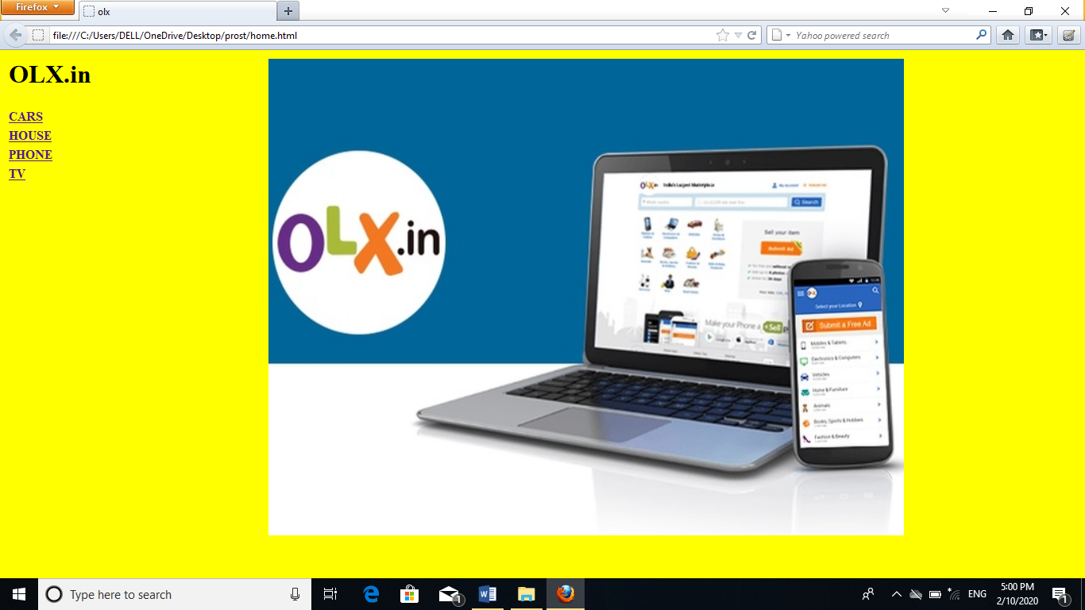
OUTPUT
